Excel guide 1 – Basic variable description
Histograms or box-and-whisker plots for quantitative (continuous) variables
- Select the column you’re describing (e.g., click on the letter just above the variable name)
- Under the Insert tab, select statistical charts and choose a simple Histogram (first option) or Box and Whisker
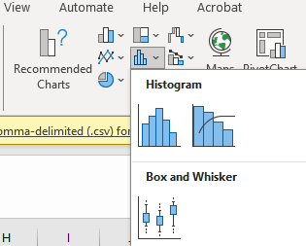
- Click on the graph
- Under the Format tab on the top ribbon, click Format Selection (all the way to the left)
  - For histograms, click to edit the Horizontal Axis:
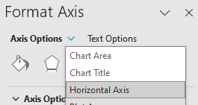
  - For box and whisker plots, click to edit the Vertical Axis instead
- Select the button that looks like a bar chart:
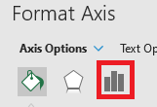
- Make adjustments to settings, as desired:
  - For histograms, adjust the bin widths
  - For box and whisker plots, under “Axis Options,” adjust the minimum and maximum
Descriptive statistics for quantitative (continuous) variables
Before you start, make sure you install the Analysis toolpak (instructions on how to do so here: https://support.microsoft.com/en-us/office/load-the-analysis-toolpak-in-excel-6a63e598-cd6d-42e3-9317-6b40ba1a66b4)
- To check if it’s installed, click Data on the ribbon, and then see if there is a button for Data Analysis on the right:
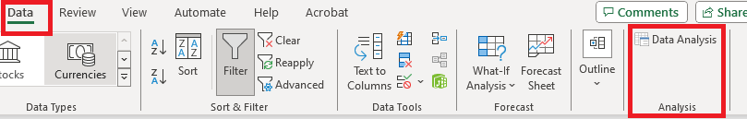
Get the descriptive statistics
- Under the Data tab, click “Data Analysis”
- Select “Descriptive Statistics” and click OK
- Click inside the box for “Input Range,” then click to select the column you’re describing
- Make sure the box “Labels in first row” is selected
- For “Output options,” I recommend “New Worksheet Ply”
- Make sure the box “Summary statistics” is selected
Frequency tables + bar charts for qualitative variables (often also works well for ordinal or discrete variables)
1. Make the initial pivot table
- Make sure your variable has a name entered in the first row
- Under the Insert tab, click “PivotTable”
- Make sure the variable/observations you want are selected; if not, you can click in the box for “Table/Range,” then click to select the column you’re describing
- For choice of where you want the PivotTable, I recommend “New Worksheet”
- On the right (PivotTable Fields), click-and-drag your variable name down to the box called “Rows” or “Axis”
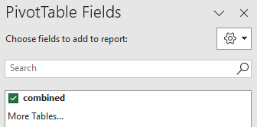
- Now, click-and-drag your variable name down to the box called “Values”
- In the Values box, click the small triangle to select, then choose “Value Field Settings”
- Select the “Count” option, then click OK
2. Make the bar chart
- A bar chart may automatically appear; if not, follow these steps:
  - Click any cell inside the pivot table
  - Under the Insert tab, click to add a 2-D Column bar chart (Clicking “Recommend Charts” may give you this as the default option)
- Make any desired adjustments to formatting/labeling, and then copy-paste the bar chart out of Excel before completing step 3 (step 3 will alter the bar chart by adding extra and unnecessary bars)
3. Add percentages to the pivot table
- Returning to “PivotTable Fields,” click-and-drag your variable name down to the box called “Values” again (the variable needs to be listed twice under “Values”)
- In the Values box, click the small “select” triangle for this second listing of your variable, and choose “Value Field Settings”
- Select the “Count” option, and then click on the “Show Values As” tab
- Select “% of Column Total,” then click OK

